WEEK 2 - 2015-11-03

**5 - Basic Git Commands**

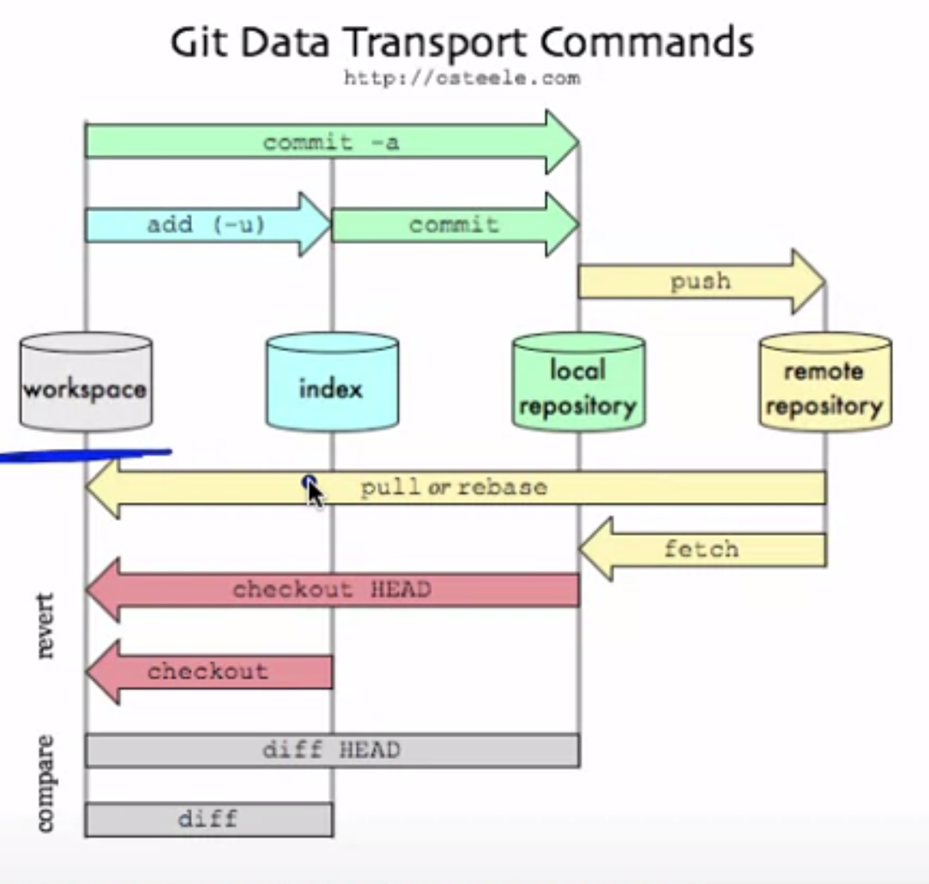

**Adding to Index (before commiting)**

Suppose you add new files to a local repo under version control

You need to let Git know that they need to be tracked

* **git add .** adds all new files
* **git add -u** updates tracking for files that changed names or were deleted
* **git add -A** does both

**Commiting**

You have changes you want to commit to be saved as an version

* git commit -m “message - description of what you did”
* This only updated **LOCAL** repo

**Pushing**

Update remote with local files

* **git push**

**Branches**

If alot people uses same version

You may not want to edit that version

So you can create a branch with the command

* **git checkout -b branchname**

To see what branch you are on type:

* **git branch**

To switch back to the master branch type

* **git checkout master**

**Pull requests**

If you fork someones repo or have multiple branches you wll both be working on seperately

Merge your changes into other branch/repos

Click button in GitHub

**Need help?**

GitHub help

Google/Stack Overflow